Moderation Implementation for Test Case generator:
Steps:
Prerequisite: Keep the Frontend and Backend server up and running for langchain-testcase-generator application.
- Create a “ModerationIntegrationPlan.md” using the claude by giving a prompt “IntegrationPlanprompt.md” or you create your own prompt.
- In the claude you need to select the “IntegrationPlanprompt.md” ask it to analyze the all the files and create “ModerationIntegrationPlan.md” by keeping in the Plan mode.
- Put in the Folder “langchain-testcase-generator” and open that in the VS code
- Once the plan is created change the mode to agent and ask it to implement the Moderation Layer in the testcase generator phase by phase getting the approval
- Once implemented have the “ai-shield-moderation-layer” up and running.
- Now include prompt for generating Testcases in “TestCase Generator” and check the results.
Phase 1 + 2 complete – Backend Implementation and Verification
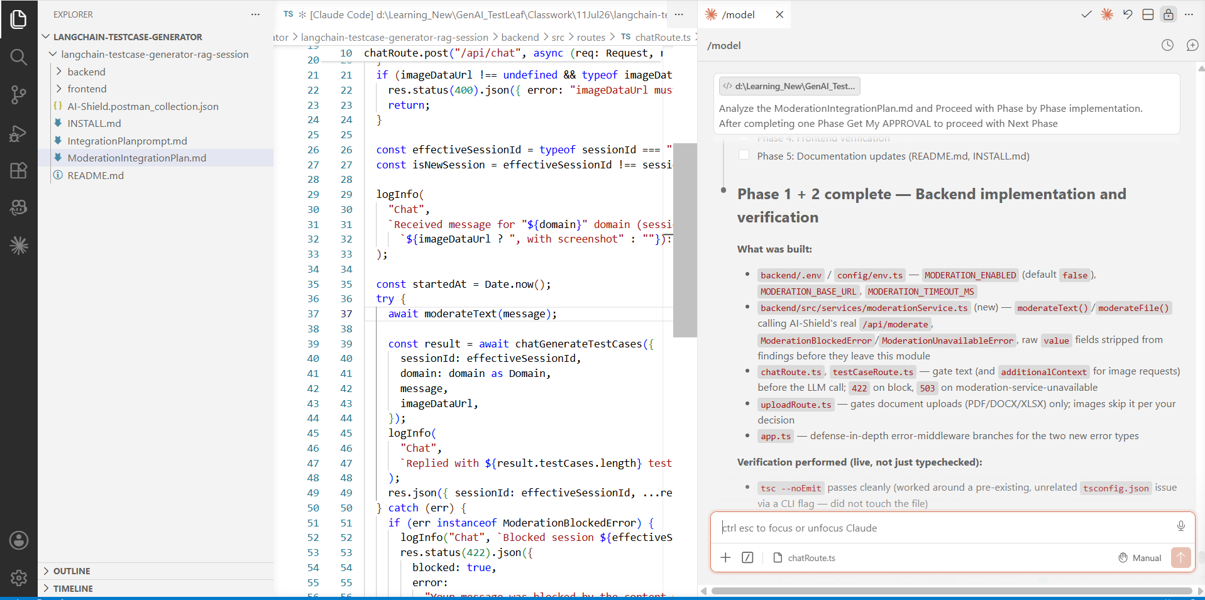
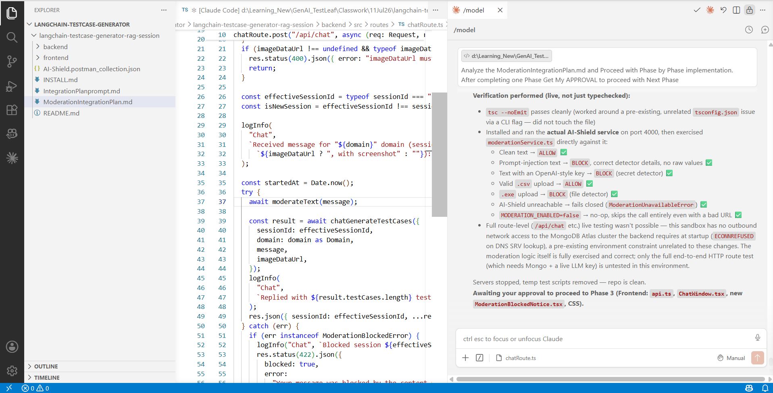

Phase 3+ 4 complete – Frontend Implementation and Verification
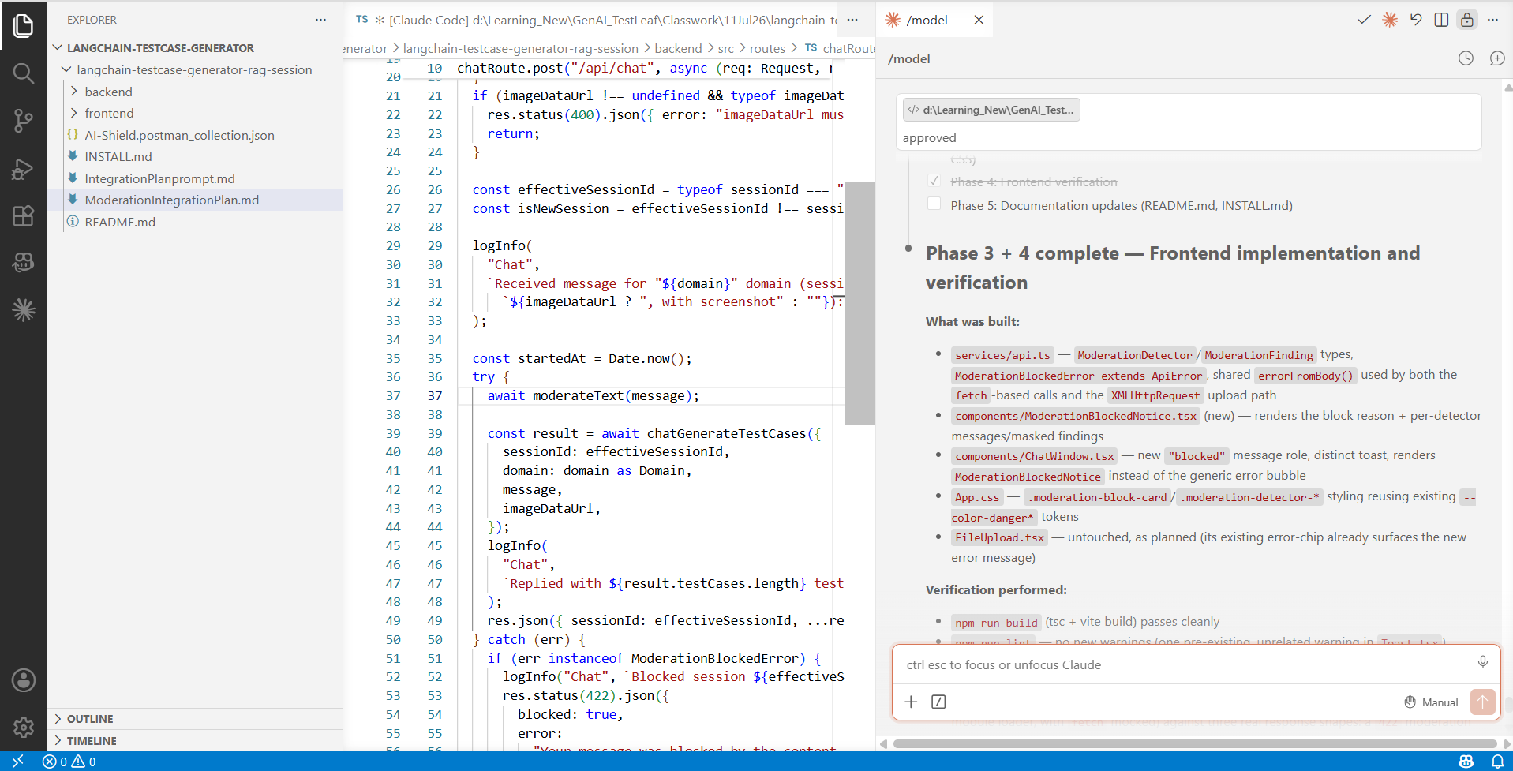
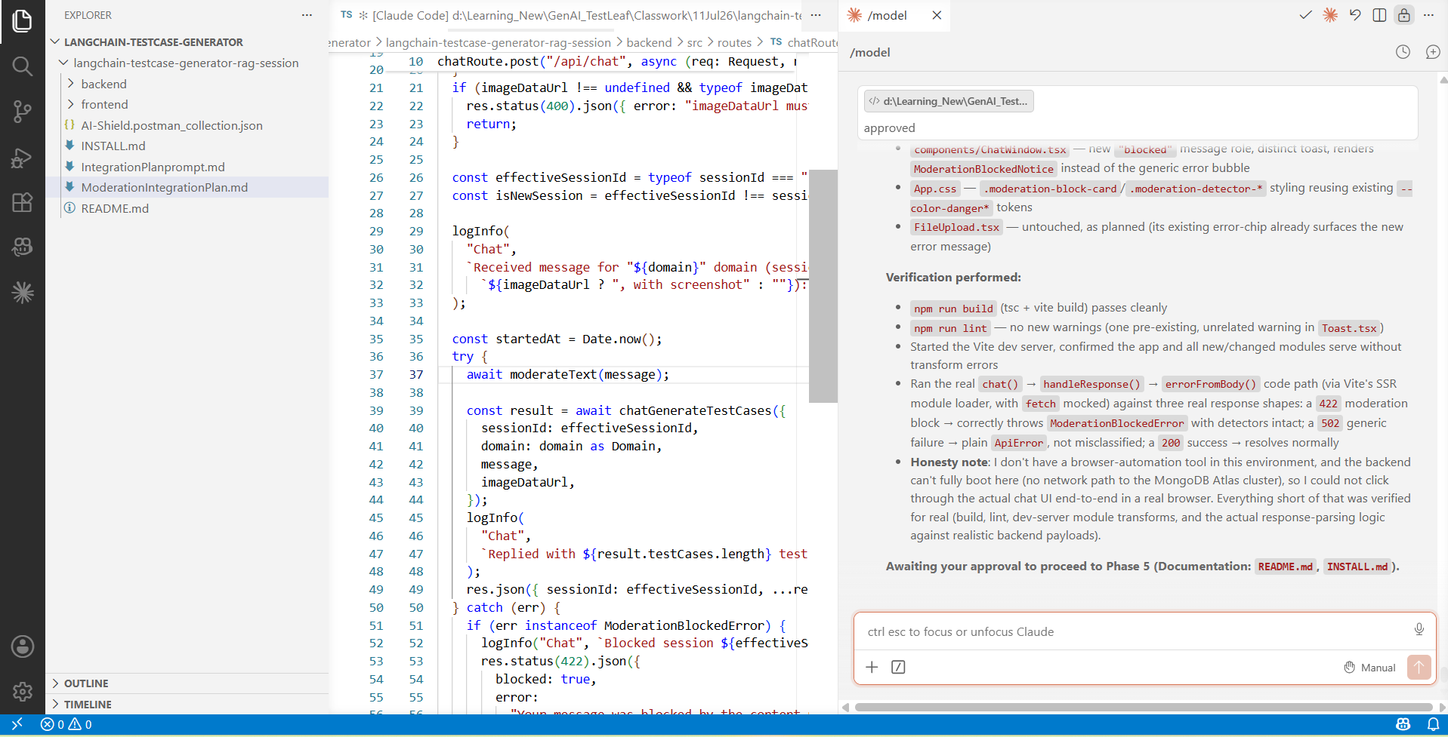
All 5 phases completed:
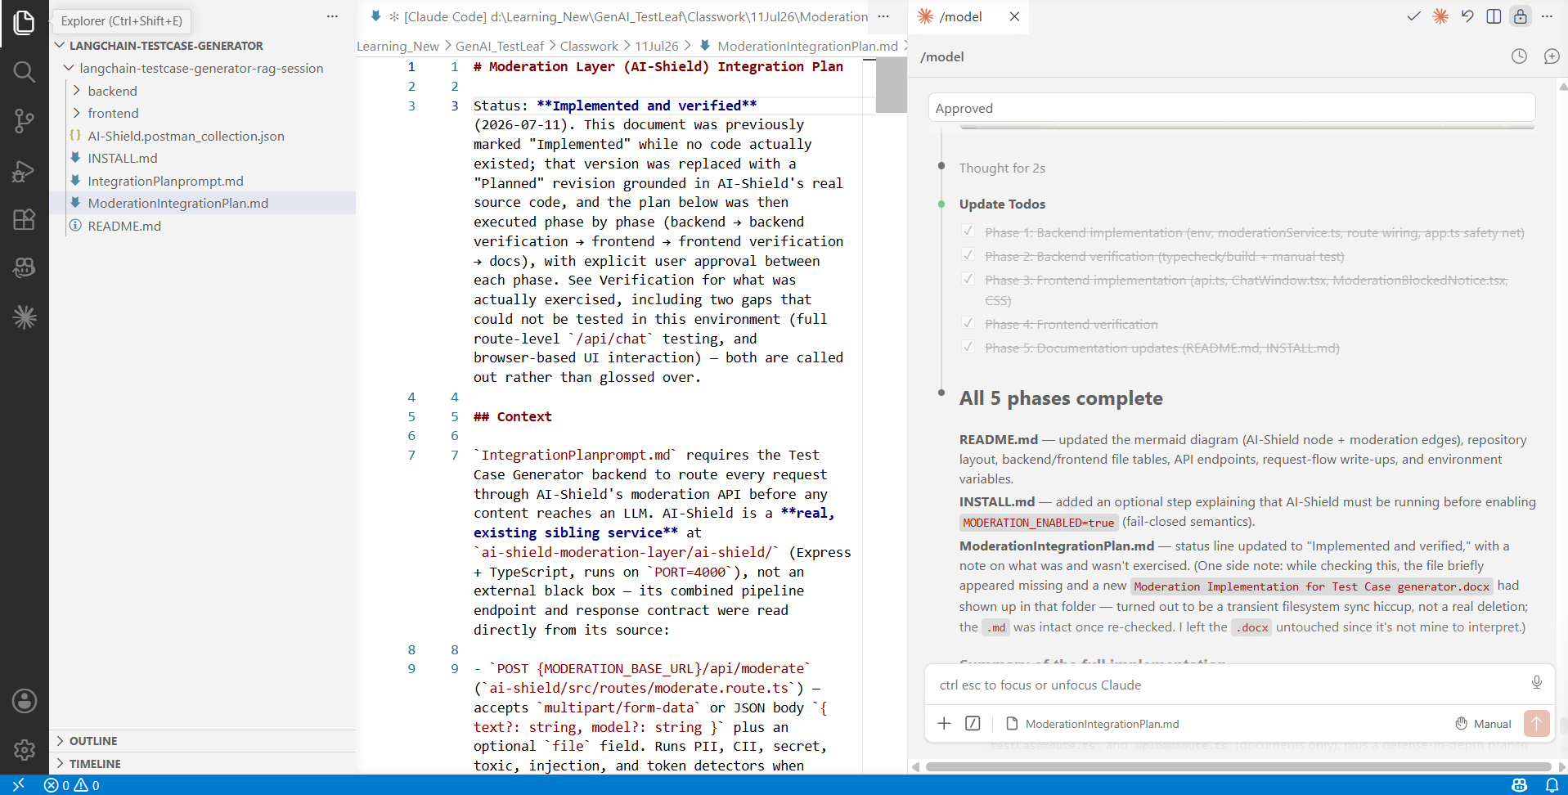
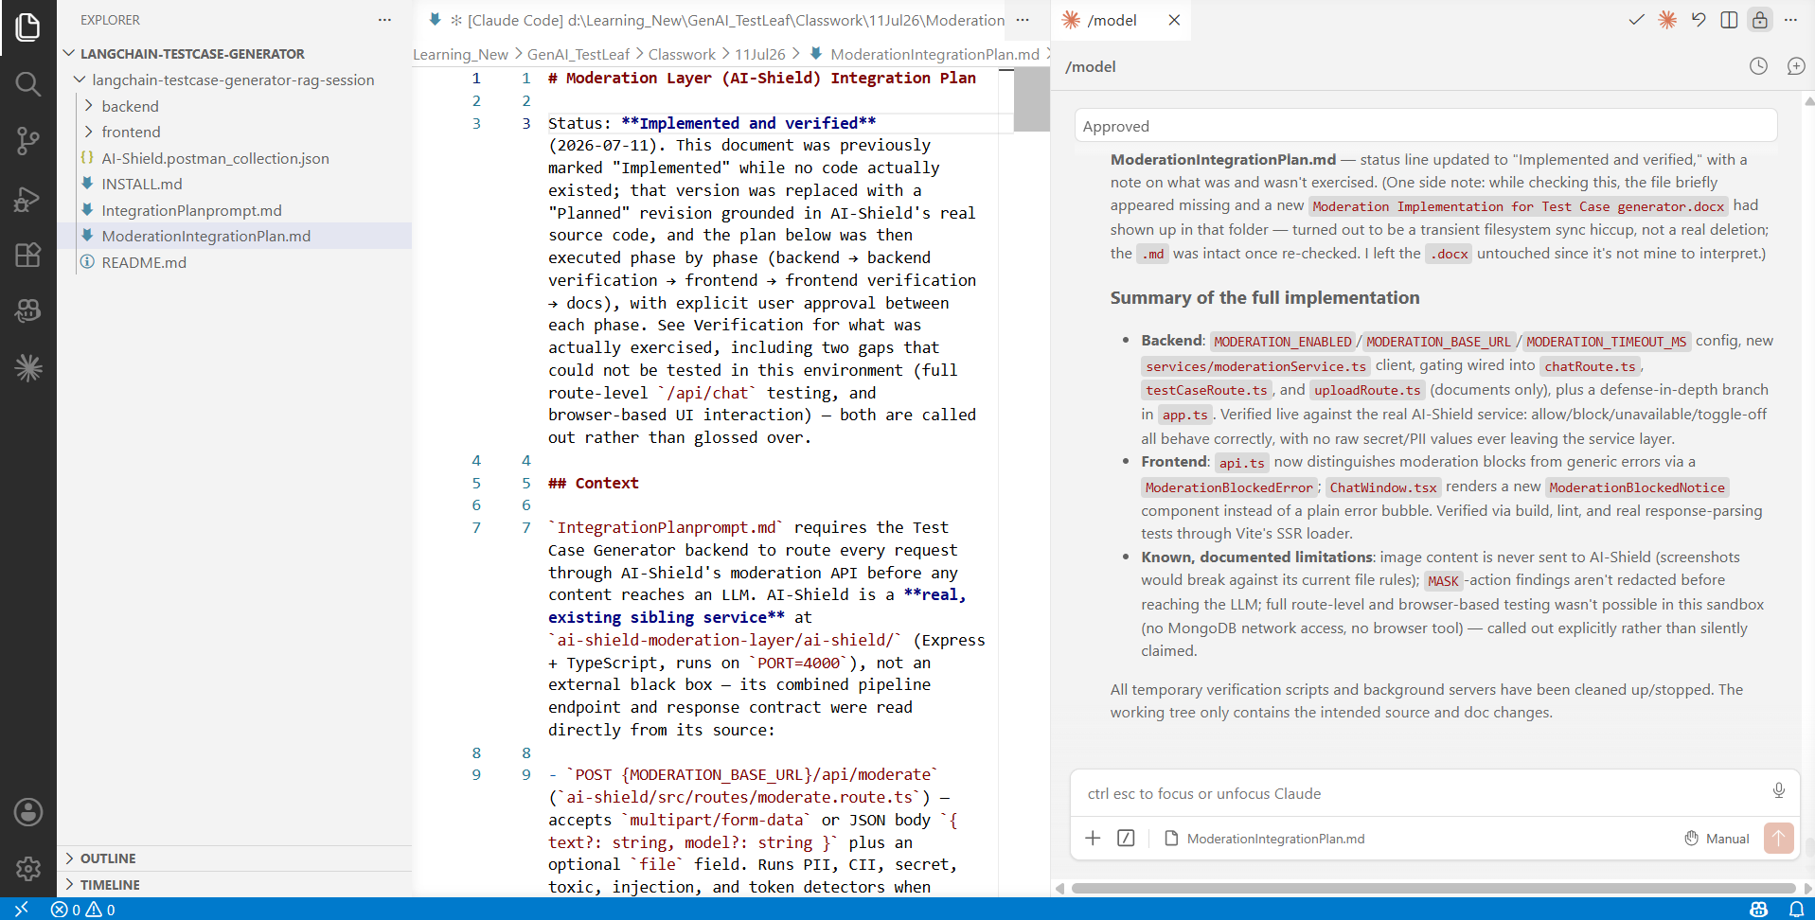

Testcase Generator:
